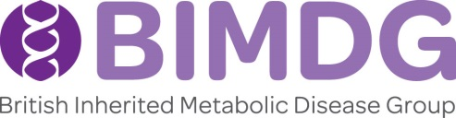
BIMDG Annual Symposium 2022
Thursday 9th & Friday 10th June – Hilton Hotel Gateshead, Newcastle upon Tyne
MEMBERS PAPERS ABSTRACT APPLICATION FORM
There will be a session of 6 short presentations chosen from abstracts and poster submissions (15 minutes each to include discussion time) by members of the BIMDG, on the Friday morning. There will also be 8 short 2 minute presentations on the Thursday afternoon. Topics do not need to relate to the meeting’s programme.
Information to be included in box: title of abstract, authors and affiliations, summary of material to be presented. Please ensure that if a case report is presented, in your abstract/presentation that the patient/guardian has given permission. If your abstract is successful a disclaimer to this effect MUST be included.
The accepted abstracts will be reproduced in the BIMDG bulletin. There will be a prize for the best two presentations.
Maximum number of words: 200
Name of Presenting Author and Department:
E-mail address:
Title of Abstract:
Co-Presenting Authors:
I am submitting this as a (please delete those that are not required) :
Presentation Poster Both
Abstract (200 words):

Deadline for submitting an abstract : Friday 8th April 2022 by email to jmassociates1@me.com
Jacqui McAleer, JM Associates for BIMDG, Hill Farm Cottage, Woodford, Kettering, Northamptonshire, NN14 4JD. Tel : +44 1832 731747

